UD003 Intended Use, Functionality, Design and API Reference on the Module utils.docstring_parsers.py

Scope
This document provides reference information on the module utils.docstring_parsers within the library pos, wherein a set of classes is defined, which can either extract specific data related to the automatic documentation generation form the module’s, class’, method’s or function’s doc-string, or to produce a reduced version of the doc-string with all such data removed.
The four most widely used formats for the auto-documentation are supported:
- Epytext (based on the javadoc format)
- reST (as reStructured Text format)
- Google Python documentation format, as well as the super-set of this format with additional tokens employed by the author of the library (Anton Azarov)
- NumPydoc format
The implemented classes are:
- GenericParser
- EpytextParser
- reSTParser
- GoogleParser
- AAParser
- NumPydocParser
Two helper functions are defined as well:
- guess_parser(): returns the most appropriate parser class based on the efficiency of the auto-documentation data removal
- indent_docstring(): returns a “copy” of the original doc-string with all lines additionally indented by the same amount of spaces

Functionality and Intended Use
The primary goal of this module is to provide functionality for the generation of the ‘pretty’ formatted textual information as the introspection of the “live” objects (as classes, their instances and attributes) from the doc-strings of the classes themselves as well as their methods and data descriptors.
The doc-strings are intended for the in-line documentation of the code, and they are useful during the analysis of the source code as well as during the introspection of the “live” objects, e.g. by using the built-in function help(). The absolute minimum of what they should do is to describe what a function / method / class does. Since Python is a dynamic binding programming language, the definition of a function / method fixes only the number and order of the parameters, but not their types. Furthermore, the function / method definition does not define the return value(s) type. In short, unlike the static programming languages, the function / method definition does not define its signature.
Often it is useful to provide information on the meaning, types and / or values range of the arguments, that are expected as the input (regardless of how the ‘wrong’ input is treated), as well as of the returned value(s), and the types of the exceptions, which can be raised, and in which situations they are raised. Such information is, usually, nothing more than ‘hints’ for the user, unless the strict data sanity checks are implemented (e.g. using Design by Contract approach). However, such information is expected to be present in the ‘good’ code. Moreover, there are plenty of tool for the automatic documentation generation, which expect that information in the docstrings in one of the common formats (see above).
On the other hand, inclusion of such information into the docstrings greatly increases the volume of the docstring, and the output of the built-in function help() becomes really bloated, especially when a class or its instance is inspected.
The solution within pos library is to implement the modified introspection functionality within the most base ABC, which is inherited by all other classes derived from it. With this solution the actual doc-strings of a class and its methods are stripped of all auto-documentation related lines, when a class or its instance is inspected, but the method’s signature, names of the arguments, returned value(s) type and possible exceptions and contract (if available) are added to the description of the method / data descriptor. This approach results in more compact yet more detailed output than the built-in function help(), which also has the same ‘look’ regardless of the actual format of the auto-documentation employed within the doc-string.
When a method / data descriptor of a class / instance is introspected, its docstring is shown mostly as it is (except for, possibly, the indentation and the leading / tailing empty lines), whereas additional information on the arguments names and order is to be provided.
The secondary goal of the module is to provide means for the “off-line” automated documentation generation (without importing the modules into the interpreter’s environment, i.e. based on the analysis of the source code only) regardless of the actual format of the auto-documentation used.
Thus, the required functionality of the module includes:
- Ability to ‘beautify’ a docstring, i.e. to remove all leading and tailing empty lines, to remove all tailing whitespaces in each line, and to increase or decrease the indentation of all remaining lines uniformly
- Ability to choose the most appropriate parser class based on the format of the auto-documentation used
- Ability to remove as much as possible (ideally, all) auto-documentation related lines from a docstring
- Ability to remove the doc-test related lines
- Ability to extract ‘hints’ from the doc-string concerning:
  - names and order of the expected arguments (parameters) of the function / method
  - type(s) of the value(s) returned by the function / method
  - types of the exceptions, which can be raised by the function / method
  - explicitly defined signature of the function / method (currently, only for the Google’s format super-set used by AA)
The intended use cases of the module are shown in Illustration 1.
This functionality is implemented according the following logic:
- The auto-documentation related lines are recognized by format-specific tokens
- The token must be the first non-whitespaces sub-string of the line (residual indentation is ignored)
- The token defines the start of a text block: one or several lines – whereas the end of the text block is identified either by an empty line (ignoring the indentation) or by another token. N.B. the official Google Python documentation format allows inclusion of several paragraphs within a single auto-documentation entry, since it also relies on the indentation. The current implementation does not support the inclusion of the empty line separated paragraphs! Any empty line automatically ends the entry.
- The token may be followed by the text on the same line, or the explanatory / data text can start from the next line (usually, with the additional indentation)
- In the case of the NumPydoc the actual token (as a word / words) must be underlined with the ‘-’ (minus sign), thus the next line must starts with at least one ‘-’ character (ignoring the indentation); the first two lines of the block are considered as a single token, whereas the actual text must begin at the 3rd line

References:
[1] https://stackoverflow.com/questions/3898572/what-is-the-standard-python-docstring-format
[2] http://epydoc.sourceforge.net/manual-epytext.html
[3] https://thomas-cokelaer.info/tutorials/sphinx/docstring_python.html
[4] https://github.com/google/styleguide/blob/gh-pages/pyguide.md#38-comments-and-docstrings
[5] https://numpydoc.readthedocs.io/en/latest/format.html#docstring-standard

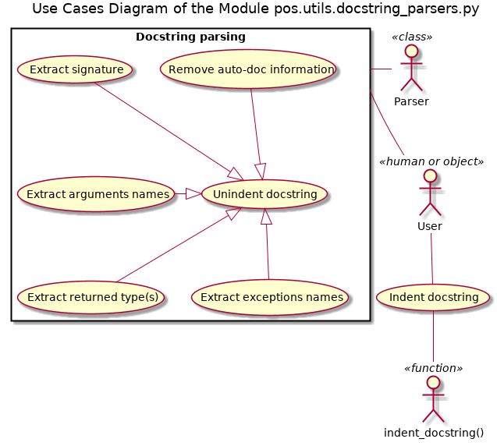Illustration 1

Design and Implementation Details

API Reference

